A Girls Networking Platform gives birth to a Junior Leader for Girls
Meet Vision Chemhere, a girl learner from Madzivire Secondary School, Buhera. Her parents separated before she started Grade 1 and from then onwards, she and her two siblings stayed with her grandmother and disabled grandfather. Up to now, she does not know the whereabouts of their parents and this in part contributed to a low self-esteem and a lack motivation in educational achievement.
She attended a Girl’s Symposium in commemoration of the 10th anniversary of the International Day of the Girl Child in October of 2022, Harare, then she was in Form 3. It was a chance of exposure and networking with other girls her age from different provinces and backgrounds. It was also an opportunity to interact with renowned women such as businesswomen, political figures and decision makers who represented role models, motivating learners to set a high standard on what that they too could become.
Before this experience, Vision narrates how she was a below average student when it came to academic performance. She was shy and timid, lacking confidence and this took a toll on her participation in the classroom and other school activities.
Participating in the symposium was an inspiration that turned her life around. She quietly observed how other learners were speaking confidently in front of the audience as they were presenting their issues. The command of the English Language that these learners were exhibiting triggered a sense of determination that made her say to herself ‘if they can do it, then why not me’. The experience motivated her to have the willpower to break out of her ‘cocoon’ and gather the necessary confidence to be able to speak out and stand for herself. The theme surrounding the symposium was on attainment of educational goals and abstaining from early marriages and this set the tone for her personal goal setting.
After returning from the camp, she approached her teachers to be granted opportunities during school assembly platforms to do various presentations that included talks and poems using the content that she had learned from the symposium. Now that she was increasingly seeing that she was emerging as a leader at her school, she further engaged her teachers to be given an opportunity to initiate a schoolgirl’s club, herself being the leader. This is when she gave herself the title ‘Junior Leader for Girls’. This increased her visibility and was again selected to participate in the International Women’s Day commemorations of 2023, where she presented a poem.
As the Junior Leader for Girls, she was responsible for molding and mentoring other adolescent girl learners to increase their confidence and assertiveness. In addition, she played a role in encouraging her peers to set educational goals, and to desist from early marriages. Her teachers attest that some of the girls who were becoming mischievous changed for the better from the positive peer-to-peer interactions that she made with them.
All this culminated in a renewed focus, attitude and confidence towards academic performance and resulted in her becoming the 3rd highest student at Madzivire Secondary School after passing 6 out of 8 subjects in the 2023 ‘O’ Level ZimSEC Examinations. She is one of the 6 out of 33 girl learners who had passes in 5 subjects and above.

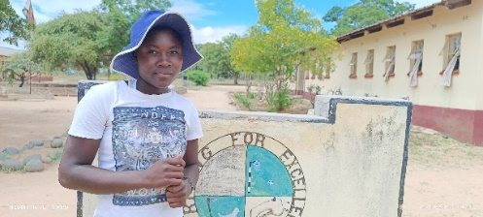
The confidence that other learners were exhibiting triggered a sense of determination that made her say to herself ‘if they can do it, then why not me?’

