**From a shy girl to a Junior Councillor**

Sarah Makumbe -Form 3 Moses the prophet Secondary School

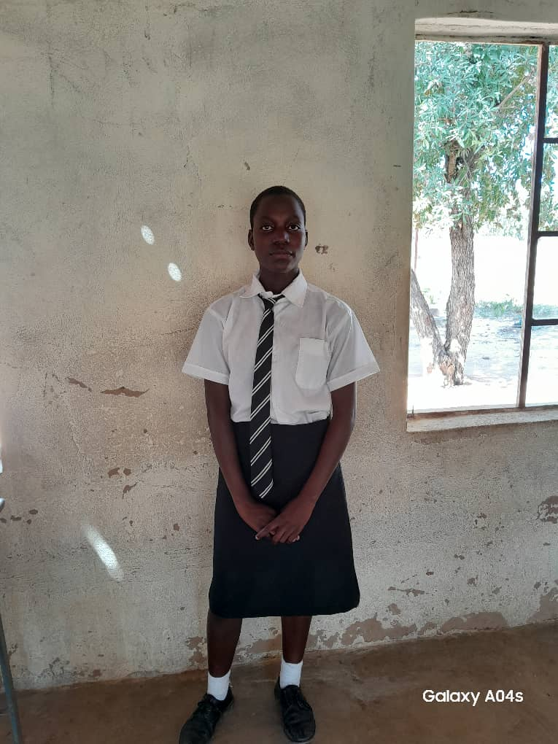

Sarah Makumbe (15) is a form three student from Moses the Prophet secondary School who resides in Muzivi village, ward 11 under headman Nemhari. Sarah is an adolescent girl from divorced parents. After the divorce of her parents at a very tender age, Sarah was adopted by her aunt (mum’s sister) who stays with her alongside her children in a household of 8 people. Growing up in a broken family, Sarah’s participation in education was always low due to poor financing as she usually struggles with getting basic for school such as school fees and stationery. This impacted her self-esteem as it was very low and her confidence levels. She always found it very difficult to present in front of other learners or participate in class and because of that, her grades were always very low. When the START4Girls project announced to the school that they were going to conduct Girls Leadership camps in May 2022, the G & C department immediately selected Sarah to be one of the Girls Leadership camp participants who was in form 1 by then.

Participating in the Girls’ Leadership camp gave Sarah a chance to develop her confidence skills and deal with her low self-esteem which was a huge barrier to achieving good results at school. In her words, Sarah highlighted that she learned about leadership and how she could also become a leader through being confident and having a voice in all issues, “ndakaona kuti ndinogona kuita mutungamiriri kana ndikagona kumiririra vamwe vangu.” She was selected to be a prefect when she was in Form 2 and was recently elected to be a junior councilor for Ward 11. She is delighted to be having this position and is grateful the START4Girls project gave her a chance to come out of her cocoon through confidence building and is now assertive.

Participating in class has improved her grades significantly from just being an ordinary learner to being an outstanding performer at the school. Sarah improved her behavior from being a shy person to a confident person who can present in front of other learners. She periodically does poems and speeches at school and in the community, and she recently won a prize of a bucket for doing health cholera awareness using poems in her community. Sarah says she is now a goal-oriented person, who is focused and is looking forward to achieving her goals of becoming a politician. She is also inspiring other learners to focus on their studies no matter their backgrounds encouraging them to break barriers.