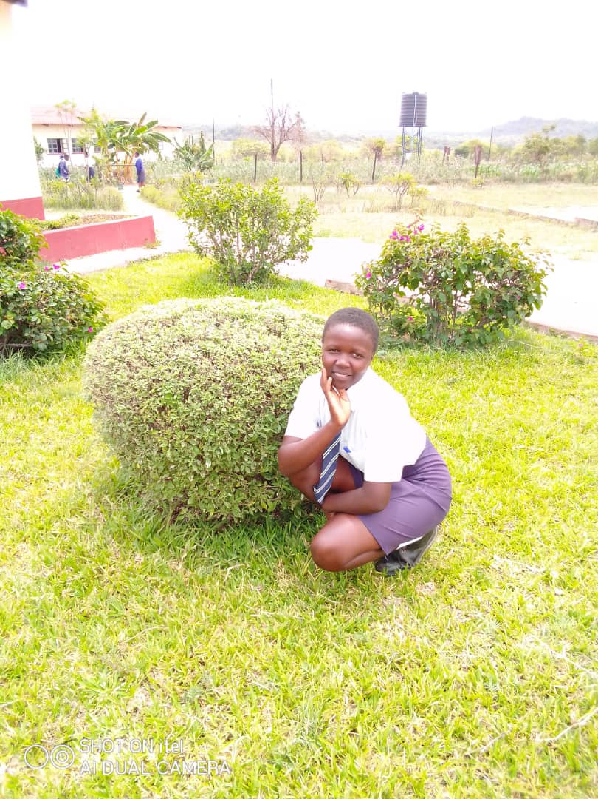

Figure 1 Marvelous Mubekapi St Johns Chifamba

Marvelous Mubekapi

Marvelous Mubekapi was cohort pupil at St Johns High School. She grew up in a maternal family. Clothing and food were always inadequate, worse still the payment of fees was unheard of. The strict school authorities would not let into the school pupils with school fees arrears. She loved school but her dreams were threatened by limited financial resources. She hoped for a time when she would not miss school and START4GIRLS was like a prayer answered. She had wished for adequate to eat, wear and school fees.

The START4GIRLS intervention came at a time when Marvelous and many like her were desperate. The project offered something for everyone with a three-pronged approach that had something for the pupil, the school, and the caregiver. For the pupil, Marvelous benefitted through the G&C lessons that offered solace to the hurting learner through guidance and counselling as a subject. The school benefited by receiving a school resilience IGA whose profits cushioned vulnerable learners. The last prong was economic empowerment which helped families save and make a living. The lack of knowledge and skills to engage in the projects to raise money to pay for school and to be self-reliant was therefore catered for in this way. Through the resilient school project, marvelous was able to get knowledge on managing an income generating activity especially the record keeping and the selection of an IGA. Her mother benefitted from the support given to VSLA groups and started An IGA at home through which fees were paid timely and Marvelous was kept in school.

Support at school through the G&C department enabled her to remain focused, the peer-to-peer networks offered a safe revision platform for her. Learning soon after the covid era was made better through the provision of face masks and the study packs which enabled fun filled learning. Marvelous stayed in school and was afforded a fair chance through which she did her best and got good results. Today she is the only member in her family that acquired 5 O’ level in one sitting. “Without START4GRLS, I would never have made it” beams Marvelous.