Story

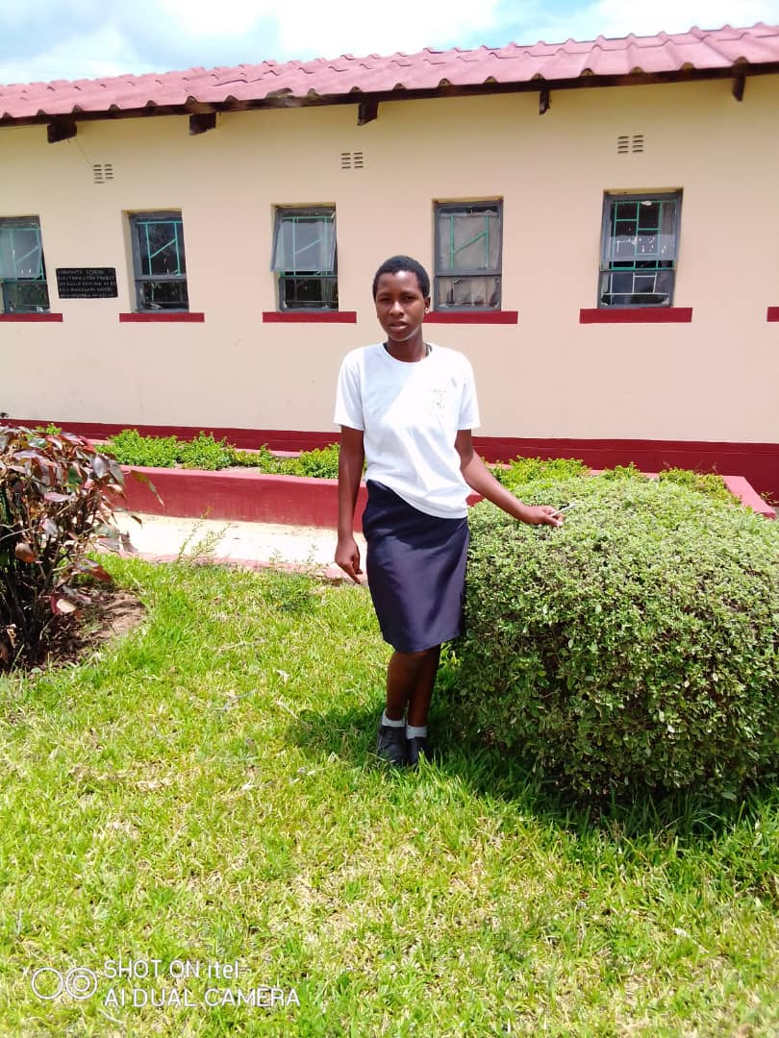

Figure 1Lorraine Nyadundu of St Johns Chifamba

Loraine Nyadundu was part of the cohort class the completed Form 4 in 2023 at St Johns Chifamba High School. The school is located 20km north-east from Murambinda Growth Point. A dusty road meanders to the newly found lithium mines that have transformed the Gaza shopping center to a hub of activity with mine labors and truck drivers more visible by the highway leading to the mines. The environment has exposed learners at St Johns to all forms of evils which include sexual abuse and exploitation with men trying to coerce learners into transactional sex, emotional abuse through the passing of lewd remarks and body shaming of pupils when they pass through the gathering points of the beer drinkers enroute to school. Girls like Loraine must contend with all of these to realize their dream of staying in school and emerging victorious in the fight against poverty and preservation of self-dignity.

The understanding of these factors influenced the interventions that the START4Girls project implemented at the school which factored the development of soft skills such as leadership, assertiveness, and agency for school pupils. Lorraine the girls’ leadership camp in May 2022 and attested to having been able to gain the much-needed soft skills which she attributes to her current success at o level. She says “Such lessons brought light in my life as a youth and consequently, I vowed to let S4G change my life as a girl child’. It was during this camp that hope was rekindled in her young heart to make it through school.

After this camp Lorraine was a changed person. She practiced what she learned and improved her focus on school. She benefitted from the Guidance and counselling to remain focused, and the teachers were able to fully support her through the counseling sessions. The full support in school through the G&C department enabled her to remain focused. The sessions helped her make new friends with the peer leaders, further supporting her newfound desire to make it through school. Exams came and Lorraine managed to reap the fruits of her efforts. When the O’ Level results came, Loraine managed to pass 6 subjects.