**Bouncing back better.**  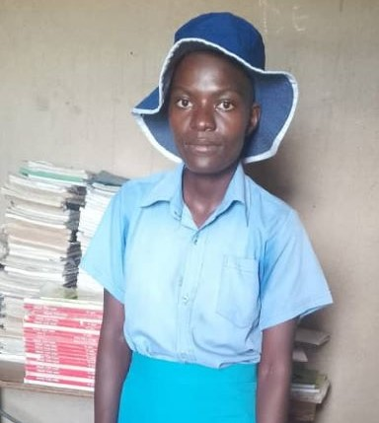

Emily Tivafire’s journey is a testament to the transformative power of education and support systems such as the government and non-profit organisations that compliments government effort such as CARE International in Zimbabwe through projects like the START4Girls project in empowering young girls to overcome adversity and continue with their education. Facing challenges early on due to her father’s passing in 2018 and lack of financial support to continue with her education and write form 4 examinations, Emily found herself in a situation where she became pregnant and got married.

Emily narrated her story “*My mother tried her best to keep me in school although the pressure was overwhelming. She sacrificed a lot to support us, doing casual work in other people’s fields. During the weekends, I used to accompany my mother for her casual work to get income. When time to register O-level examinations arrived, I failed to register due to financial constraints. During the year, my school fees was not paid. It was difficult for my family to get money and food hence I dropped out of school. During that time, I thought of looking for work as a house maid, but I was already pregnant, and I eloped to my boyfriend’s homestead in 2019. In my mind, I thought getting married was a solution to my troubles. This was a lie to myself as I was abused in the marriage by my husband. I have a baby boy from my 3-year marriage which failed to last due to abuse from my husband which I could not withstand for long”.*

Emily’s life took a difficult turn after the death of her father and the failure of her mother to support her education. These challenges led to Emily getting married at a young age and becoming a mother before completing her education. The lack of support and resources further compounded Emily’s struggles, making it seem like her dreams of pursuing an education were out of reach.

In 2023, Emily took a significant step by applying for re-enrolment at Betera High School, starting from Form 3 after an engagement with the peer leaders and G&C teachers. She chose to focus on studying science subjects, driven by her passion for the field, and committed herself to working tirelessly towards achieving her goals. This decision marked a pivotal moment in Emily’s life, showcasing her determination to pursue education despite the obstacles she had faced.

She stated that “Through the help of peer leaders, I was motivated and encouraged to re-enroll to continue with my education. The learners taught me the importance of education and informed me that it is possible to return to school even after getting married and having a baby. The G&C teachers visited me and my mother at home and we had a dialogue explaining to me the possibility of re-enrolling back to school. My mother understood and encouraged me to go back to school. She pledged to support me through providing school needs including school fees and taking care of my child whilst I’m at school. In 2023, I applied for re-enrollment at Betera High School starting form 3. I’m focusing on studying science subjects because that’s where my passion is, and I’m working tirelessly to ensure that I will achieve my goals”.

The START4Girls project played a crucial role in providing Emily with the necessary support and resources to re-enter the educational system and pursue her academic interests. By creating a conducive environment that fosters learning and empowerment for young girls, initiatives like START4Girls enable individuals like Emily to break free from societal constraints and fulfil their potential.

Emily’s dedication to her studies and her unwavering commitment to her goals exemplify the resilience and strength that can emerge when girls are given the opportunity to access education and support systems tailored to their needs. Her success story serves as an inspiration not only to those facing similar challenges but also as a reminder of the transformative impact that initiatives like the START4Girls project can have on girls’ education and empowerment.